Balancing Inquiry and Advocacy

Managers in Western corporations have received a lifetime of training in being forceful, articulate ‘advocates’ and ‘problem solvers.’ They know how to present and argue strongly for their views. But as people rise in the organisation, they are forced to deal with more complex and interdependent issues where no one individual “knows the answer, and where the only viable option is for groups of informed and committed individuals to think together to arrive at new insights. At this point, they need to learn to skilfully balance advocacy with inquiry.

When balancing advocacy and inquiry, we lay out our reasoning and thinking, and then encourage others to challenge us. “Here is my view and here is how I have arrived at it. How does it sound to you? What makes sense to you and what doesn’t? Do you see any ways I can improve it?”

Balancing inquiry and advocacy is sometimes hard on people’s cherished opinions, which is one reason why it is difficult to master. But the payoff comes in the more creative and insightful realisations that occur when people combine multiple perspectives.

We don’t recommend inquiry alone. People almost always have a viewpoint to express, and it is important to express it – in a context which allows you to learn more about others’ views while they learn more about yours. Nor do we recommend that you switch in rote fashion from an adamant assertion (“Here’s what I say”) to a question (“Now what do you say?”) and back again. Balancing inquiry and advocacy means developing a variety of skills. It’s as if all the ‘colours’ of conversation could be spread out on an imaginary palette. As the creator of your part of the conversation, you should be able to incorporate styles from all four quadrants of the palette (see diagram in next page).

The quadrants are defined by the levels of advocacy and inquiry, i.e. the relative balance of each, and can be identified by the forms of communication used within a group as described below. There are forms of constructive and dysfunctional behaviour in each quadrant.

Observing: defined by low levels of advocacy and low levels of inquiry, and characterised by the behaviours of bystanding, sensing and withdrawing.

Asking: defined by low levels of advocacy and high levels of inquiry, and characterised by clarifying, interviewing and interrogating.

Telling: defined by high levels of advocacy and low levels of inquiry, and characterised by explaining, asserting, dictating and testing (which bridges between telling and the final quadrant which follows).

Generating: defined by high levels of advocacy and high levels of inquiry, and characterised by testing, dialogue, politicking and skilful discussion.

It is said that each of us has a natural tendency to favour either inquiry or advocacy. These preferences are sometimes understood as cultural or gender related. However, they may also reflect our educational background or professional discipline. The primary points to remember are:

- A conscious effort to balance inquiry and advocacy improves group results qualitatively.
- Each of us needs a range of skills from all four quadrants in order to maximise out contribution in groups.

This palette chart, of course, is only the beginning of a categorisation of the roles which people can play in conversation. There are probably a dozen more distinct combinations of varying levels of inquiry and advocacy, each with a different impact.

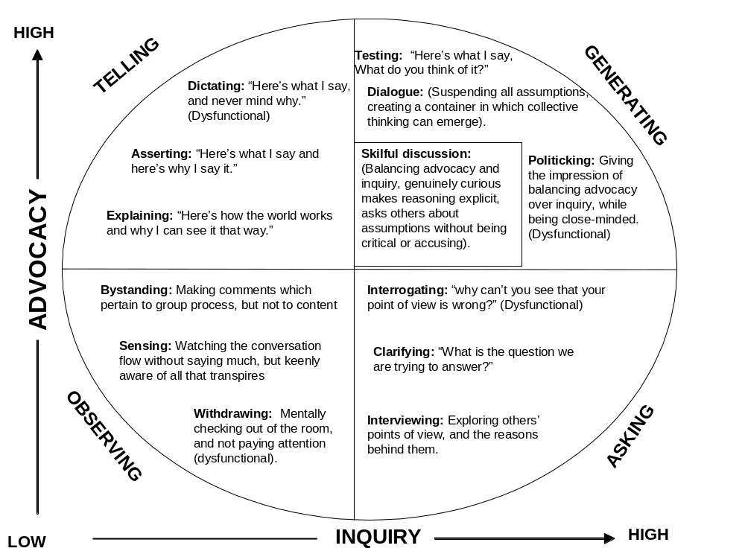

There are dysfunctional forms of both advocacy and inquiry. For example, in organisations, practiced people can skew the inquiry process by relentless ‘interrogating,’ without caring at all for the person being questioned. In the same vein, advocacy can feel like an inquisition if the advocate simply ‘dictates’ his point of view, while refusing to make his reasoning process visible. People who are unwilling to expose their thinking may also ‘withdraw’ into silence, instead of taking the opportunity to learn through observation.

One of the most destructive conversational forms is ‘politicking,’ in which there is no overt argument – just as relentless refusal to learn while giving the impression of balancing advocacy and inquiry. In workshops, we see this form sometimes when people who have read The Fifth Discipline play ‘The Beer Game’. This game is a mock production-and-distribution system simulation, demonstrating how the structure of a system determines behaviour. From the description of the game in The Fifth Discipline, some readers conclude the best winning strategy is deliberately under-ordering beer and remaining in backlog throughout the game. When these people show up to play, they cling to their mistaken impression at all costs. Their strategy is disastrous for their team’s score, and it would be disastrous in real life, because businesses which remain in backlog don’t keep their customers. Nonetheless, these players refuse to consider any other course of play. When people ask them to change for the sake of their team-mates, they don’t argue back. They simply call attention to their ‘superior’ status: “Look, I’ve read the book. Trust me. I know what I’m doing.”

It is said that each of us has a natural predilection toward either advocacy or inquiry. Debate and law teach advocacy; journalism and social work (if they’re practised well) teach inquiry. Men are rewarded more for advocacy; women are more rewarded for inquiry. In the Southern United States, women are even taught that it is a sign of poor breeding to state what you want or need. (Instead of saying, “can you get me a mint julep?” a thirsty woman would say, “It’s a terribly hot day. Wouldn’t it be wonderful if we all had some special refreshment?”) During the 1970’s, many women had a hard time with advocacy, but now that more women have joined managerial ranks in organisations, members of both genders are becoming more adept at balancing the two forms.

Protocols for balancing advocacy and inquiry
Balancing advocacy and inquiry is one way for individuals, by themselves, to begin changing a large organisation from within. You don’t need any mandate, budget, or approval to begin. You will almost always be rewarded with better relationships and a reputation for integrity.

The purpose of these conversational recipes is to help people learn the skills of balancing inquiry and advocacy. Use them whenever a conversation offers you an opportunity to learn – for example, when a team is considering a difficult point that requires information and participation from everyone on the team.

- Protocols for Improved Advocacy
Make your thinking process visible (walk up the ladder of inference slowly).
What to do | What to say
State your assumptions, and describe the data that led to them. | “Here’s what I think and here’s how I got there.”
Explain your assumptions | “I assumed that…”
Make your reasoning explicit. | “I came to this conclusion because….”
Explain the context of your point of view: who will be affected by what you propose, how they will be affected, and why.

Give examples of what you propose, even if they’re hypothetical or metaphorical. | “To get a clear picture of what I’m talking about, imagine that you’re a customer who will be affected…”
As you speak, try to picture the other people’s perspectives on what you are saying.

Publicly test your conclusions and assumptions.

Encourage others to explore your model, your assumptions, and your data. | “What do you think about what I just said?” or “Do you see any flaws in my reasoning?” or “What can you add?”
Refrain from defensiveness when your ideas are questioned. If you’re advocating something worthwhile, then it will only get stronger by being used.

Reveal where you are least clear in your thinking. Rather than making you vulnerable, it defuses the force of advocates who are opposed to you, and invites improvement. | “Here’s one aspect which you might help me think through…”
Even when advocating, listen, stay open, and encourage others to provide different views. | “Do you see it differently?”

- Protocols for Improved Inquiry
Ask others to make their thinking process visible.
What to do | What to say
Gently walk others down the ladder of inference and find out what data they are operating from. | “What leads you to conclude that?” What data do you have for that?” “What causes you to say that?”
Use un-aggressive language, particularly with people who are not familiar with these skills. Ask in a way, which does not provoke defensiveness, or “lead the witness.” | Instead of “what do you mean?” or “What’s your proof?” say, “Can you help me understand your thinking here?”
Draw out their reasoning. Find out as much as you can about why they are saying what they’re saying. | “What is the significance of that?” “How does this relate to your other concerns?” “Where does your reasoning go next?”
Explain your reasons for inquiring, and how your inquiry relates to your own concerns, hopes, and needs. | “I’m asking you about your assumptions here because…”
Compare your assumptions to theirs.

Test what they say by asking broader contexts, or for examples. | “How would your proposal affect…?” “Is this similar to…?” “Can you describe a typical example…?”
Check your understanding of what they have said. | “Am I correct that you’re saying…?”
Listen for the new understanding that may emerge. Don’t concentrate on preparing to destroy the other person’s argument or promote your own agenda.

- Protocols for Facing a Point of View With Which You Disagree
What to do | What to say
Again, inquire about what has led the person to that view. | “How did you arrive at this view?” “Are you taking into account data that I have not considered?”
Make sure you truly understand the view. | “If I understand you correctly, you’re saying that…?
Explore, listen, and offer your own views in an open way. | “Have you considered…?”
Listen for the larger meaning that may come out of honest, open sharing of alternative mental models.

Use your left-hand column as a resource. | “When you say such-and-such, I worry that it means…”
Raise your concerns and state what is leading you to have them. | “I have a hard time seeing that, because of this reasoning…”

- Protocols for When You’re at an Impasse
What to do | What to say
Embrace the impasse, and tease apart the current thinking. (You may discover that focussing on “data” brings you all down the ladder of inference.) | “What do we know for a fact?”  “What do we sense is true, but have no data for yet?”  “What don’t we know?”
Look for information which will help people move forward. | “What do we agree upon and what do we disagree on?”
Ask if there is any way you might together design an experiment or inquiry which could provide new information.

Listen to ideas as if for the first time.

Consider each person’s mental model as a piece of a larger puzzle. | “Are we starting from two very different sets of assumptions here? Where do they come from?”
Ask what data or logic might change their views. | “What, then would have to happen before you would consider the alternative?”
Ask for the group’s help in redesigning the situation. | “It feels like we’re getting into an impasse and I’m afraid we might walk away without any better understanding. Have you got any ideas that will help us clarify our thinking?”
Don’t let the conversation stop with an “agreement to disagree.” | “I don’t understand the assumptions underlying our disagreement.”
Avoid building your “case” when someone else is speaking from a different point of view.

Confronting ‘Duelling Logic’s’
When you confront someone who represents a ‘duelling logic’ to your own apply the following construct:
- Grant legitimacy and assume the best:
- Assume that others believe their views are well-grounded
- Assume that others are seeking to do the right thing
- Assume that others might see things you miss
- Assume that you might see things others miss
- Assume conflicting views are a source of important learning

- Say how you get to your conclusions:
- Recount the data you selected
- Say how you hear those data in your words (i.e. paraphrase)
- Say what conclusions you drew from these data (as you heard them)

- Inquire of others:
- Seeking missing data that might influence the conclusions you drew
- Seek other ways of interpreting the data you have

- Ask others to say how they arrive at their views:
- Ask others to provide the data they have selected
- Ask others how they get from these data to their conclusions

Finally, recognising that we are all ‘partially sighted’, i.e., that we have blind spots, can help in this process.
What I Can See  What I am up against  What I am trying to do  How you do what you do  What effect you have on me | What I Cannot See  How I do what I do  What effect I have on you  What you’re up against  What you’re trying to do

Having Skilful Business Conversations
How to improve balancing inquiry and advocacy
- Become aware of the data you choose to give weight to and the assumptions you make about that data.
- Listen, acknowledge, explore 9inquire), explain (advocate)
- To improve advocacy:
  - Sate your assumptions and describe the data,
  - Which led to them
  - Make your reasoning explicit
  - Invite others to examine your reasoning and conclusions
  - Refrain from defensiveness
- To improve inquiry:
  - Gently walk others “down the ladder of inference”, finding out what data they are using to create their assumptions
  - Draw out others’ reasoning; find out as much as you can about why they are saying what they are saying.
  - Check your understanding of what others say
  - Remain persistently curious about new understating; don’t concentrate on destroying the others’ argument or promote your own agenda
  - Actively maintain balance between amount of inquiry and advocacy in your conversation.

Adapted from Senge, P., Kleiner, A., Smith, B., Roberts, C. & Ross, R. (2011). The Fifth Discipline Fieldbook: Strategies and Tools for Building a Learning Organization. Hachette UK.

